**RILWAN AJELERO**

**EXPLANATION ON CALCULATORS BUILT IN EXCEL**

**Content**

* Introduction
* Body

Explaining each of the calculators

* Conclusion

**INTRODUCTION**

The purpose of this report is to give explanation on each calculators on how have done it and how it works and to also explain some of the special functions on excel which have been used in building the calculators.

**SS1.1**

One of the first thing before starting the calculators was to import data into my spreadsheet and where I got the datas I imported into my spread sheet was from datas on moodle. How I imported the data was by first getting the data from moodle and copy the amount of data I think is needed then save my data into a notepad before going to my excel to import them from my notepad which is shown below

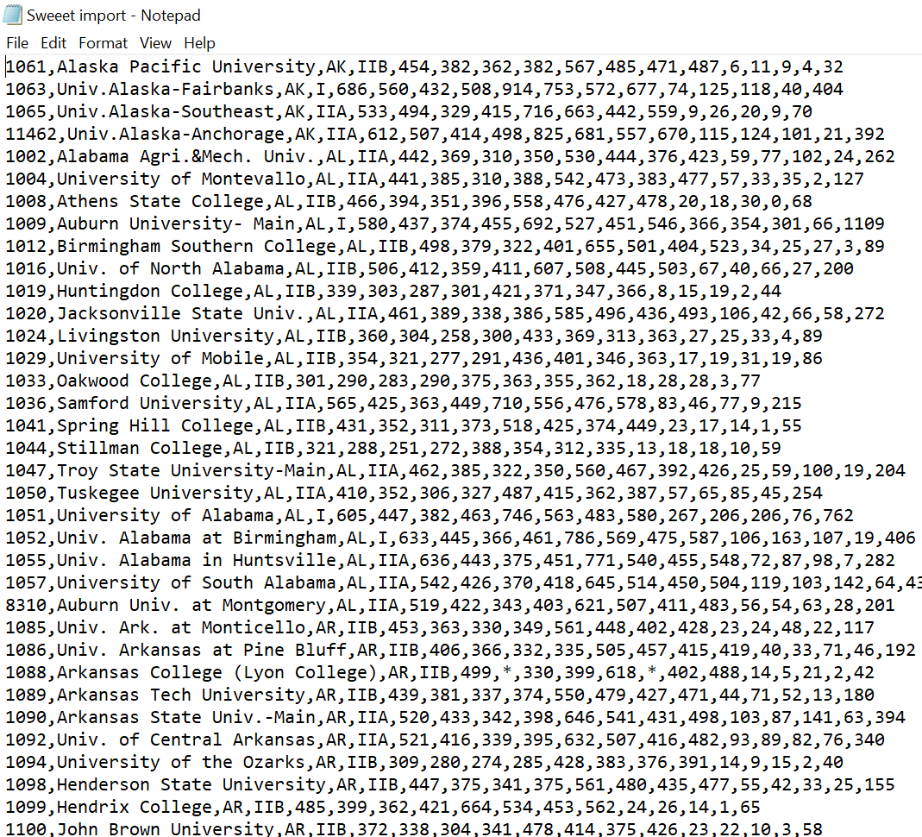

The Data’s from Moodle before putting into excel and this are saved to my notepad.

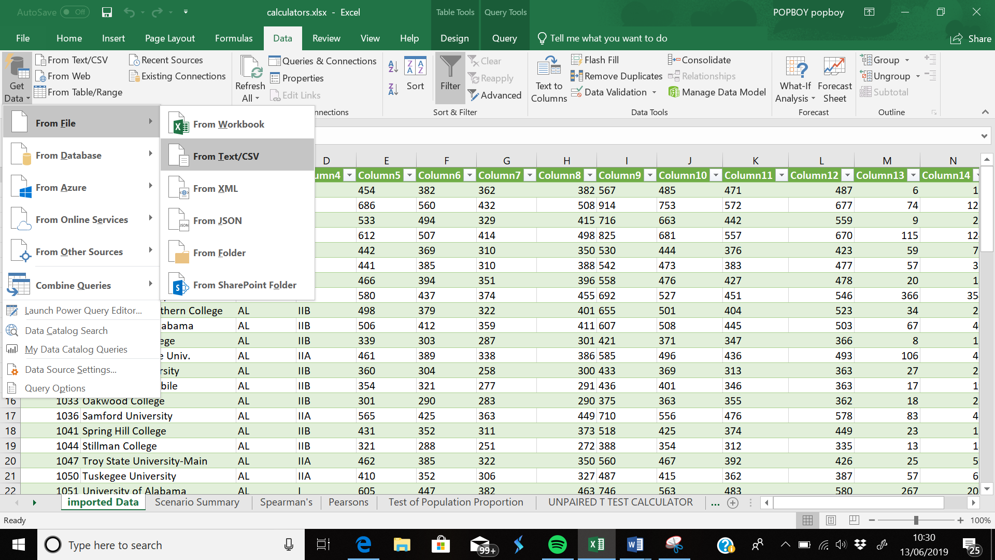

How the data was imported into excel by right clicking Data on the top menu on excel and left clicking on the top left corner **Get Data** and next is to click on **File** and from **TEXT/CV**

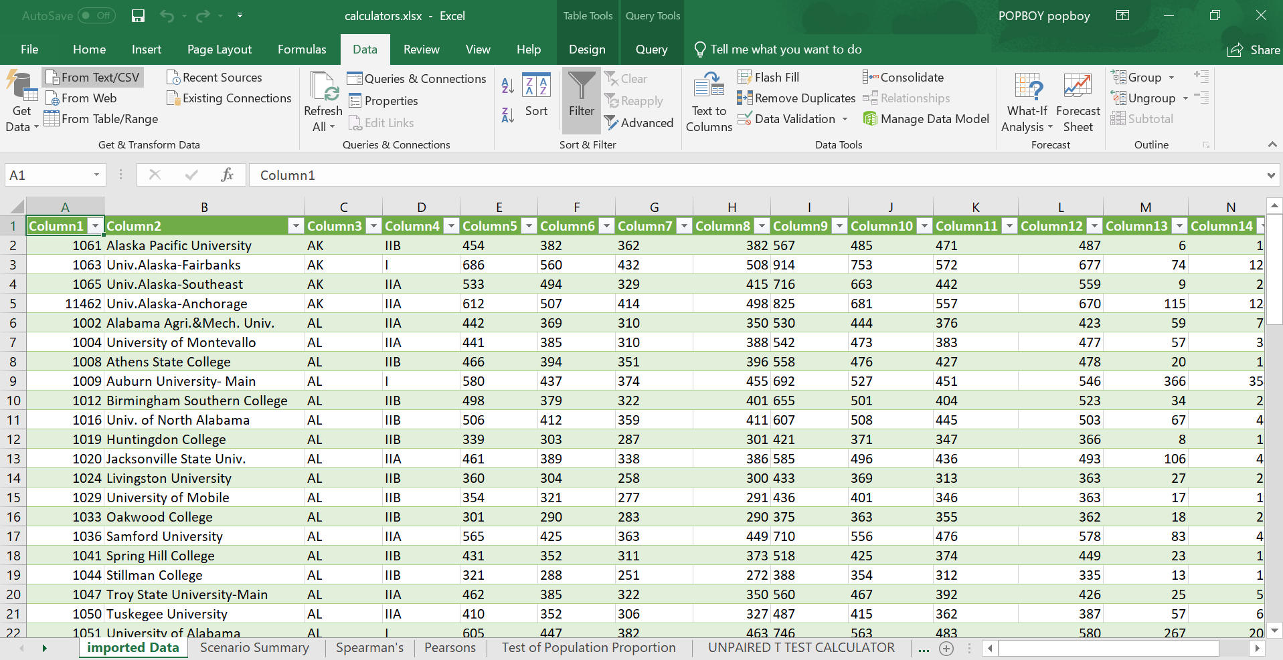Imported data

**SS1.2**

Below are the variety of formats have used /inputed into my calculators.

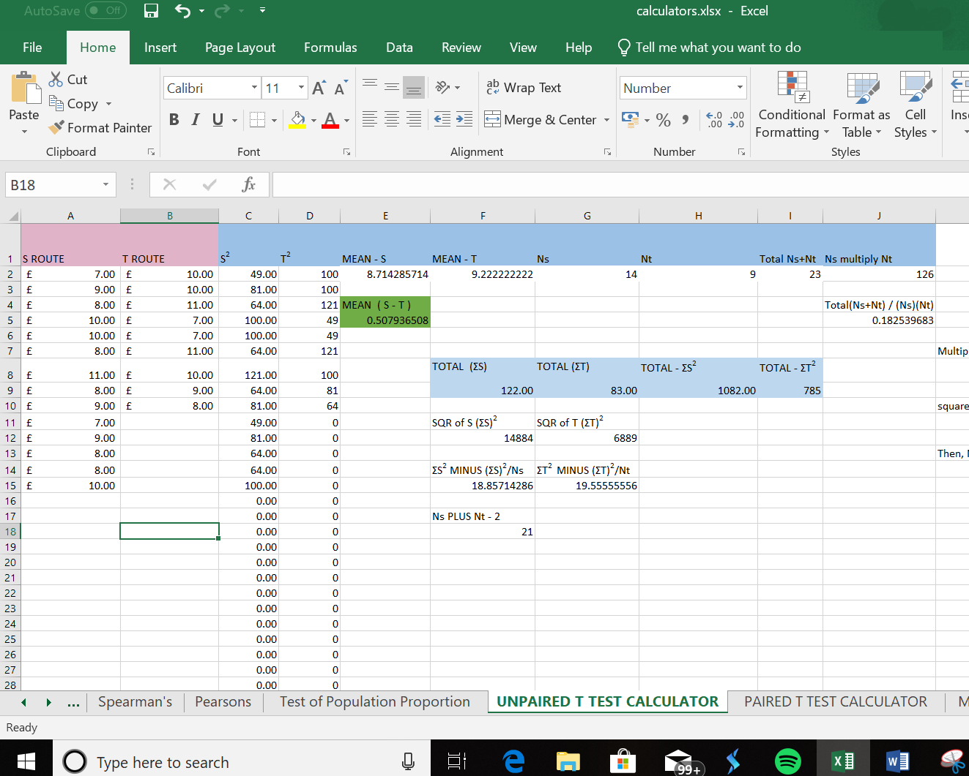Inputting the british currency into my data.

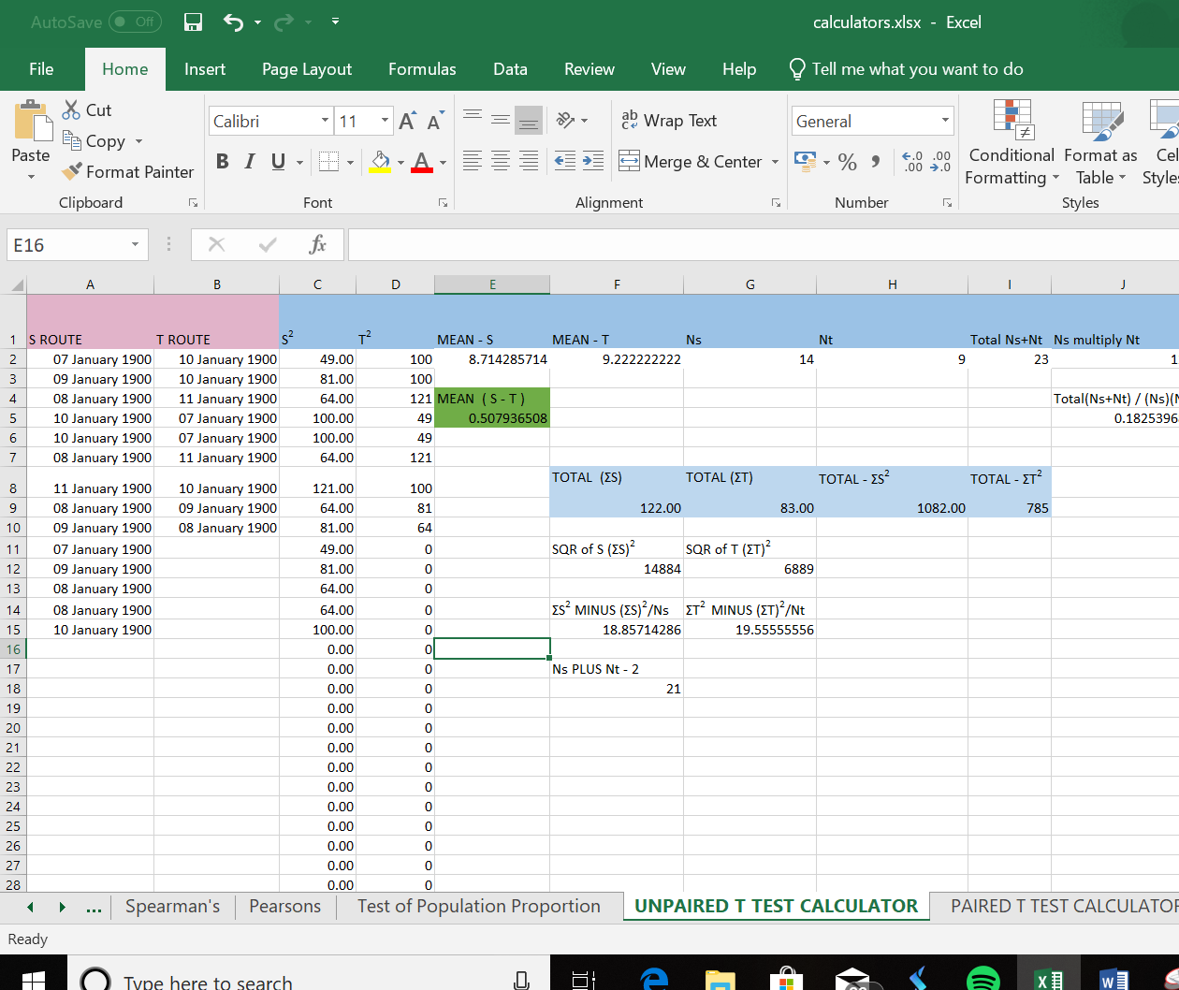

Using the Long date format

**SS1.3**

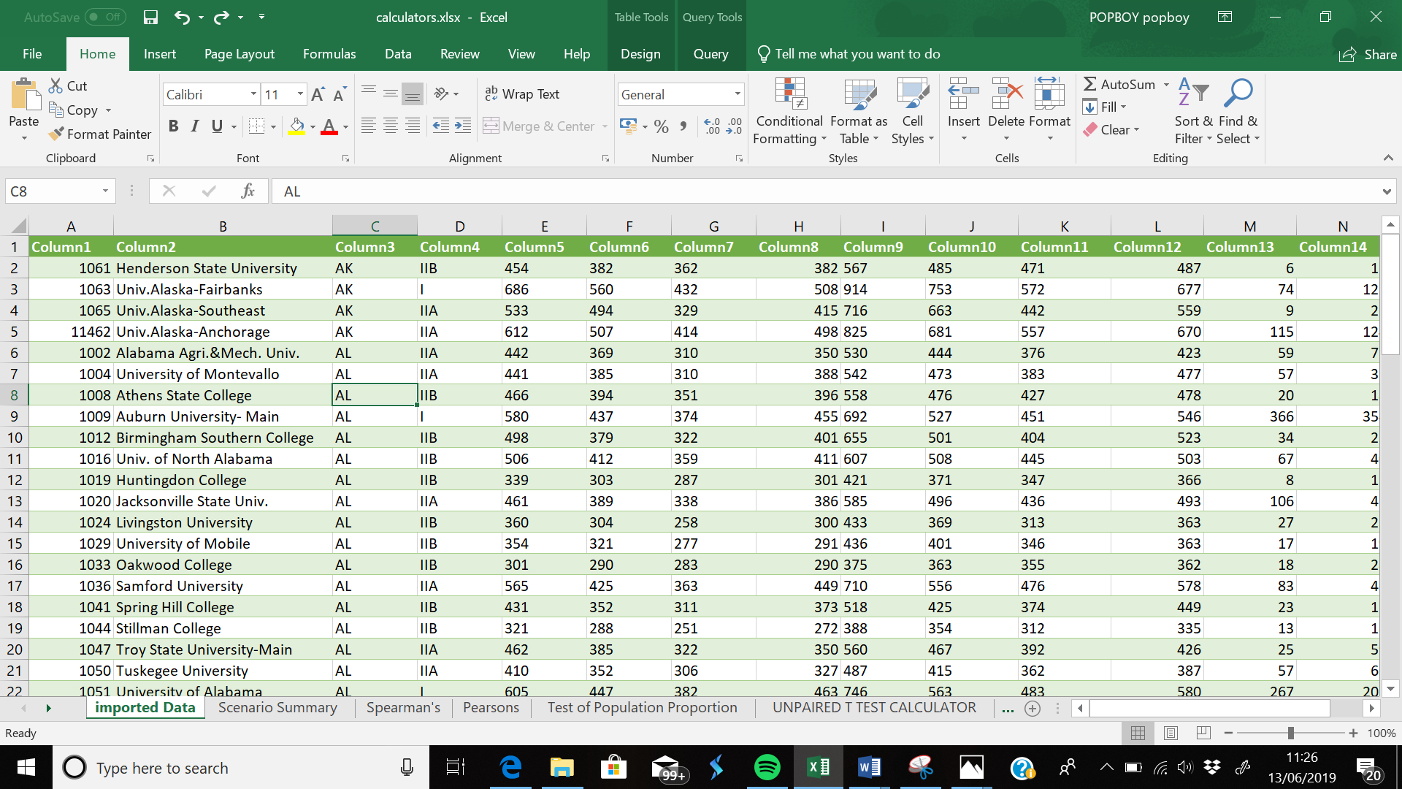

**T**his is my imported data that are not sorted yet and want I want is to arrange **column 2** of my data which is nthe names of the universities or college to be arranged alphabetically which is shown below in the next diagram

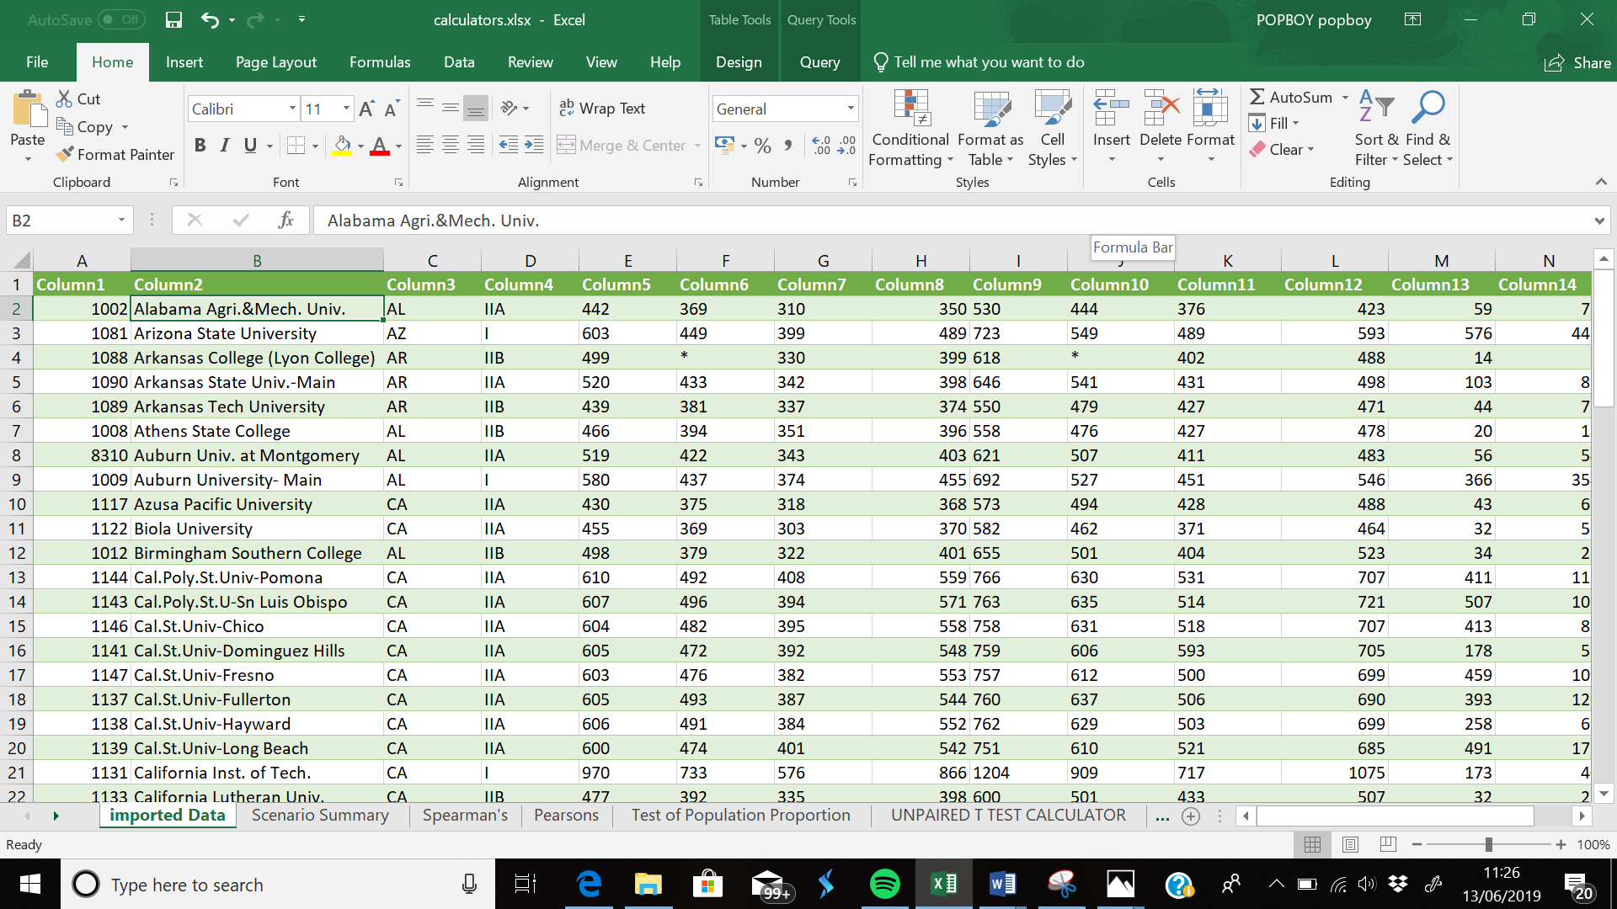My data was sorted by clicking on the first cell then clicking on **sort and filter**, and telling excel to sort Alphabetically from A – Z and below is another data which I sorted by using the sort and filter to sort the numbers from the largest numbers to the smallest.

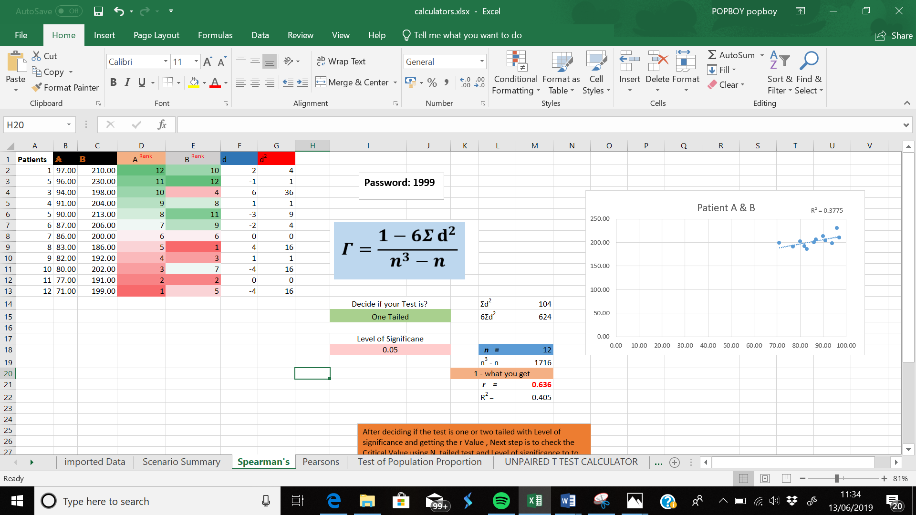

**SS1.4**

In my Spreadsheet I have used a range of conditional format and comments which after I get a results I need my calculator will tell me if the data is good enough for the arguments or significant enough to reject hypothesis or accept, and all comments used in all calculators will be explained below

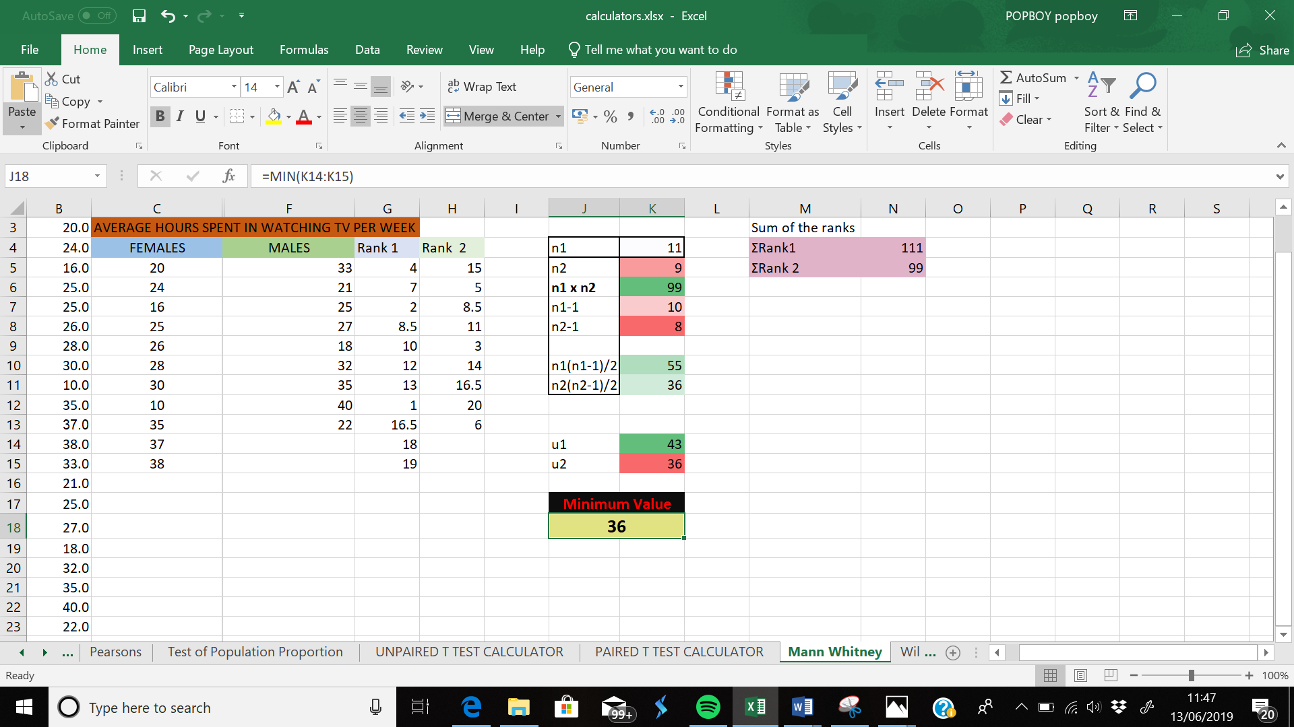

As shown above in the Mann Whitney Calculator after getting the two U’s/U values excel will then give out the minimum value between the two which is shown above in cellK14 (43) and K15(36) which then excel tells the minimum values between then which is 36.

The formula to do this is “=MIN” which then the numbers will be highlighted, so excel can give the minimum value between the range of numbers.

Another conditional formatting is using the data bars in the Wilcoxon calculator to make it very easy to visualize values in a range of cells. A longer bar represents a higher value. which is shown below

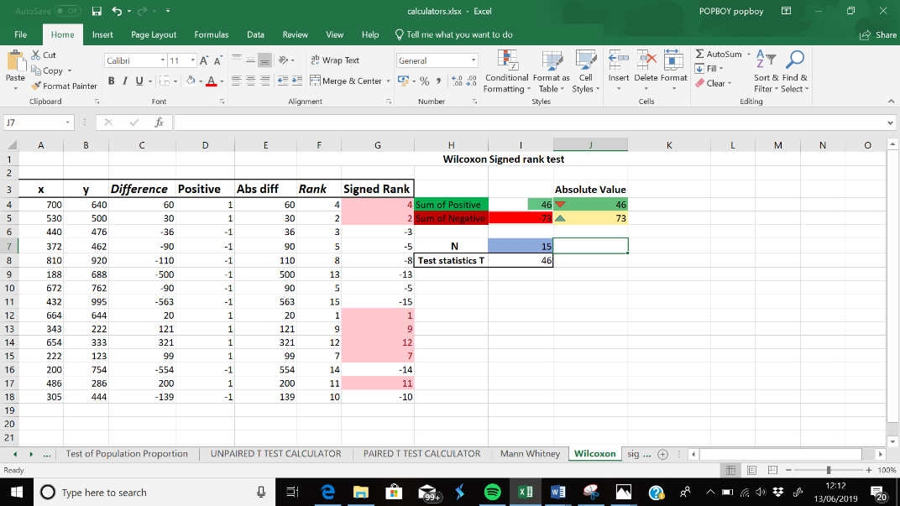The data bar is used in **cell I4 and I5** , which is telling me 46 is bigger than -73 showing green for 46 and red for -73 but what I needed was to do an absolute value to put the same number in positive then use the icon sets to represent the smaller and larger value **in Cell J4 and J5** the red triangle facing down means 46 is the lower number out of the range of number displayed.

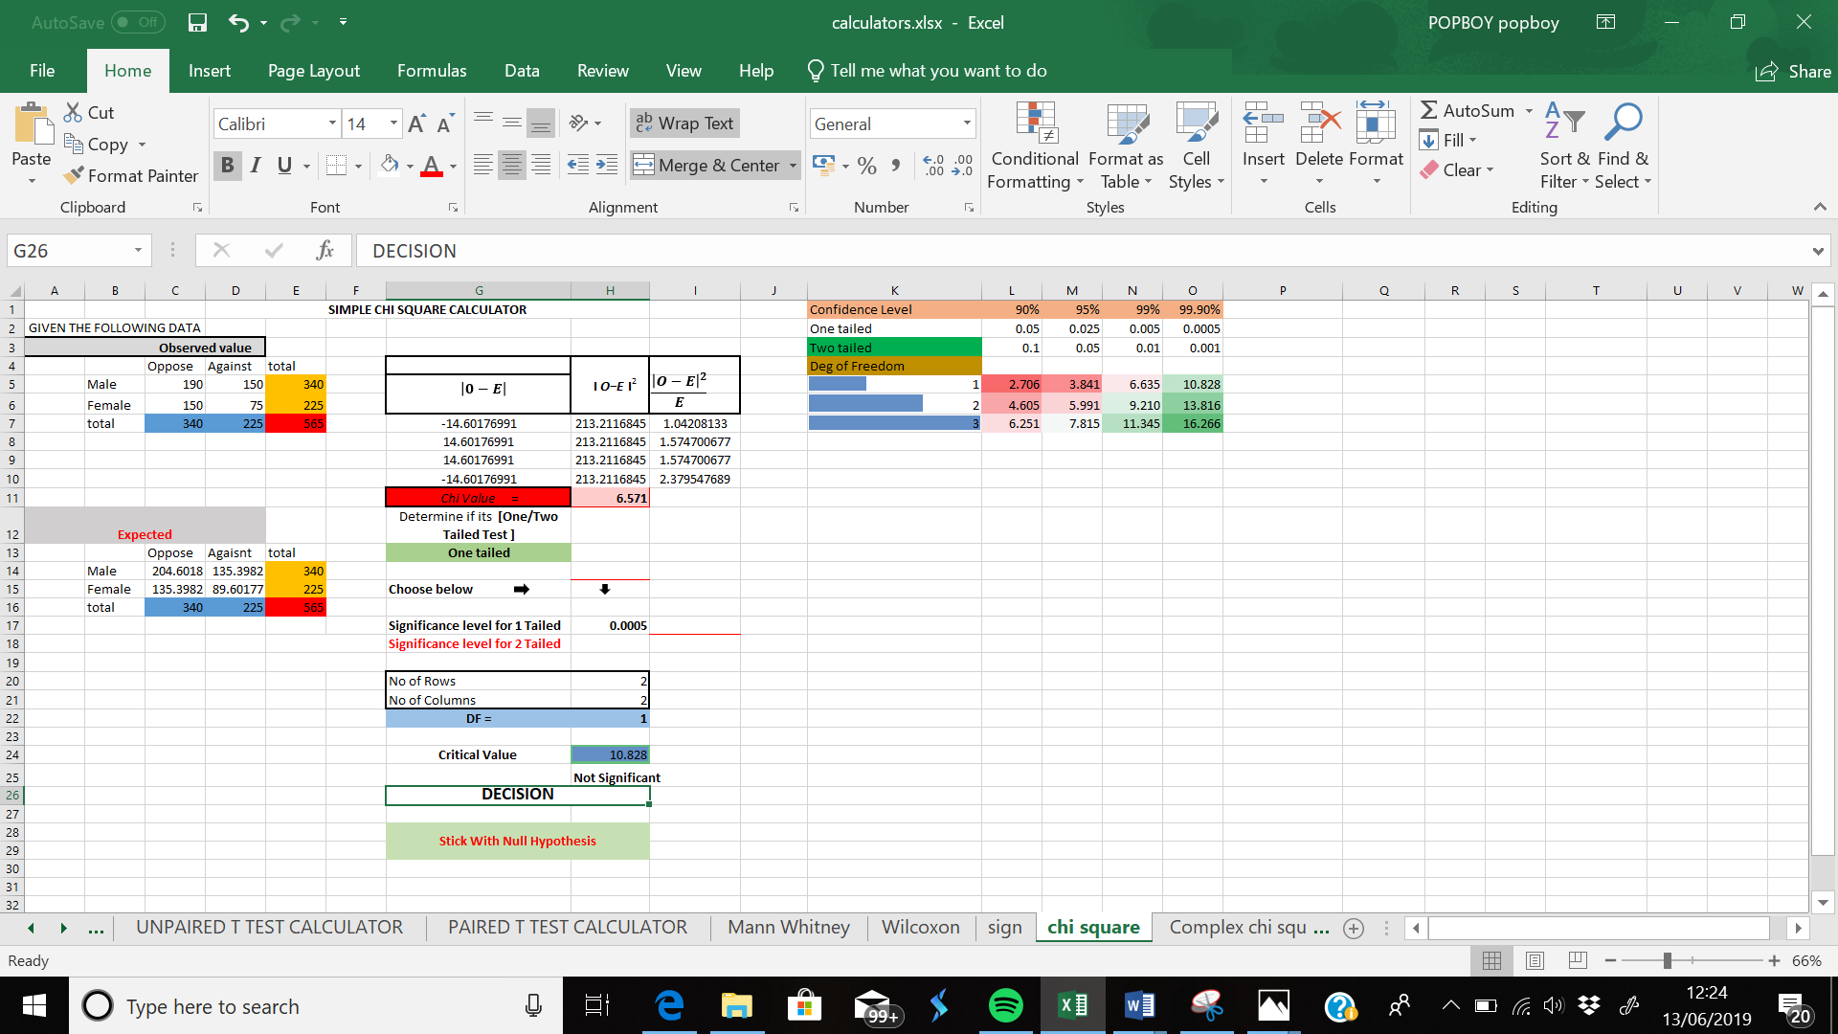Lastly the last two comments used in my calculators are in my chi simple and chi complex square calculators the comments shown is to tell the user if results gotten from the chi value and the critical value obtained from the critical value table is significant to conclude deo go for a accept the Null hypothesis or reject hypothesis or claims made.

In my Simple chi square calculator, after getting the chi value and Excel getting the critical value from the critical value table which have built in my calculator. Cell H25 Will tell if the my result is significant enough or Not to Accept my null or Reject alternative and to do that I have used the IF function to tell excel if Cell H11 is greater than or equals to cell H24 means it is significant and if not it should display not significant, to do this I typed in “**=IF(H11>H24,"Significant",IF(H11=H24,"Significant","Not Significant"))”**and also used the same IF function to do same with the decision rule below

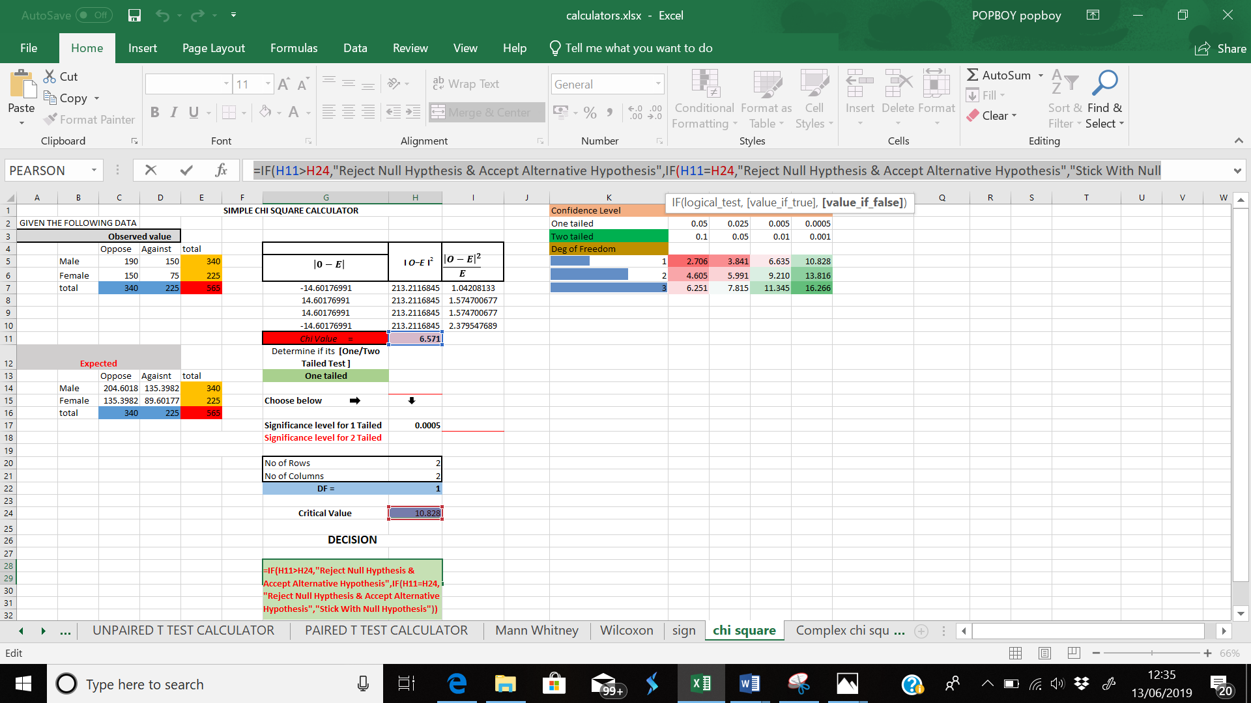

To do this I typed in **“=IF(H11>H24,"Reject Null Hypthesis & Accept Alternative Hypothesis",IF(H11=H24,"Reject Null Hypthesis & Accept Alternative Hypothesis","Stick With Null”**

**SS1.5,SS2.1,SS2.2**

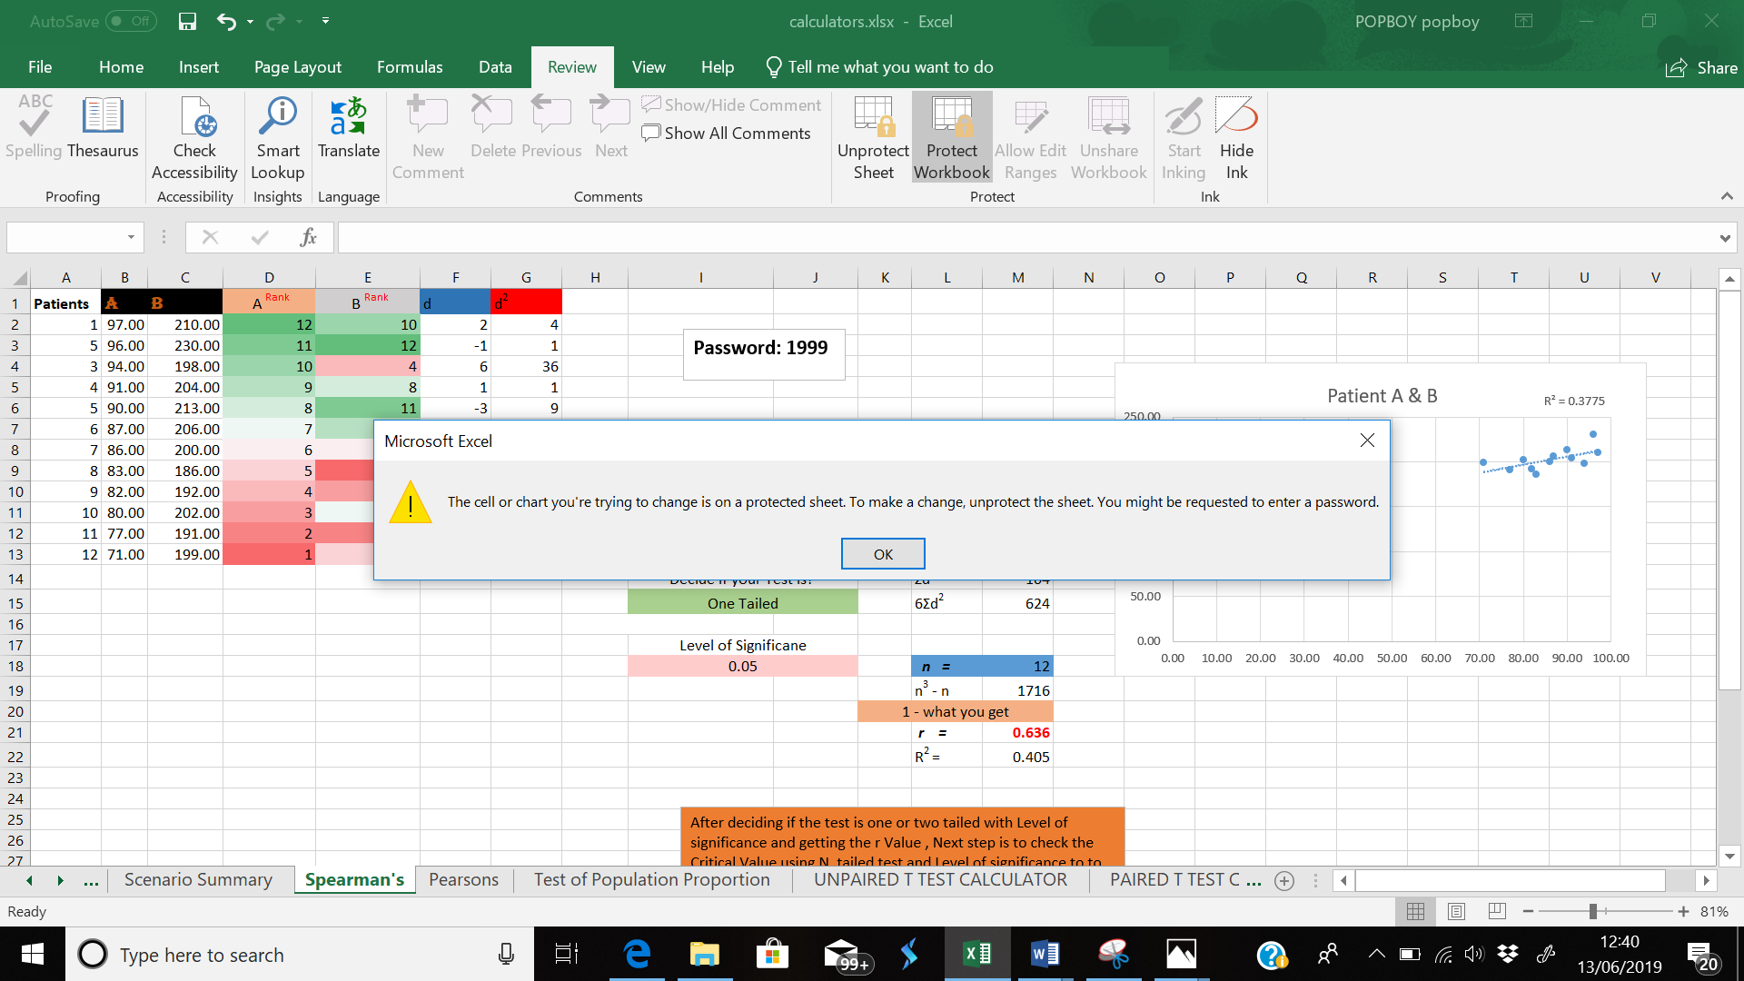Protecting my worksheet which is the spearmans sheet calculator is to protect it from someone else having access to it and to protect my worksheet I went to review which is displayed above then click on protect work sheet and protect workbook which then display this below by not allowing any the user to do any of the list shown unless they unprotect the worksheet and before having access to the sheet a password is required,before they can edit any of the information displayed

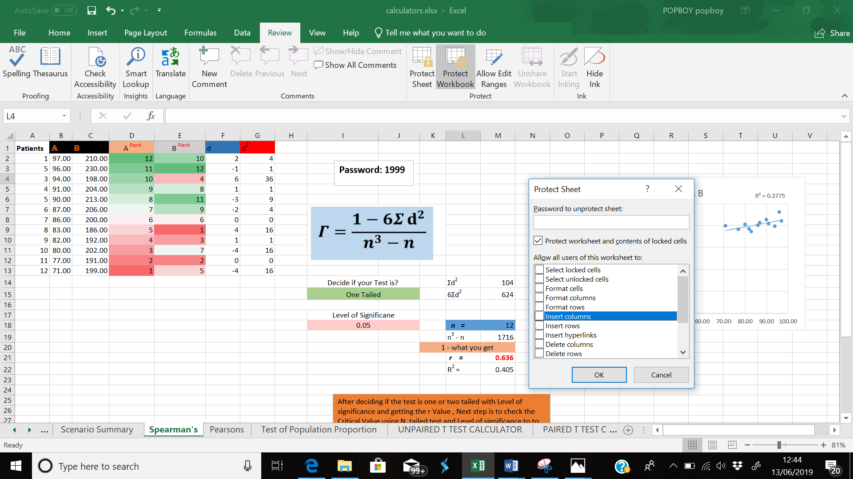

**SS2.3**

Linking data between Worksheets, I linked the data in my spearmens sheet and pearsons sheet but using the sum of the all values under row B and C into Pearsons which is displayed below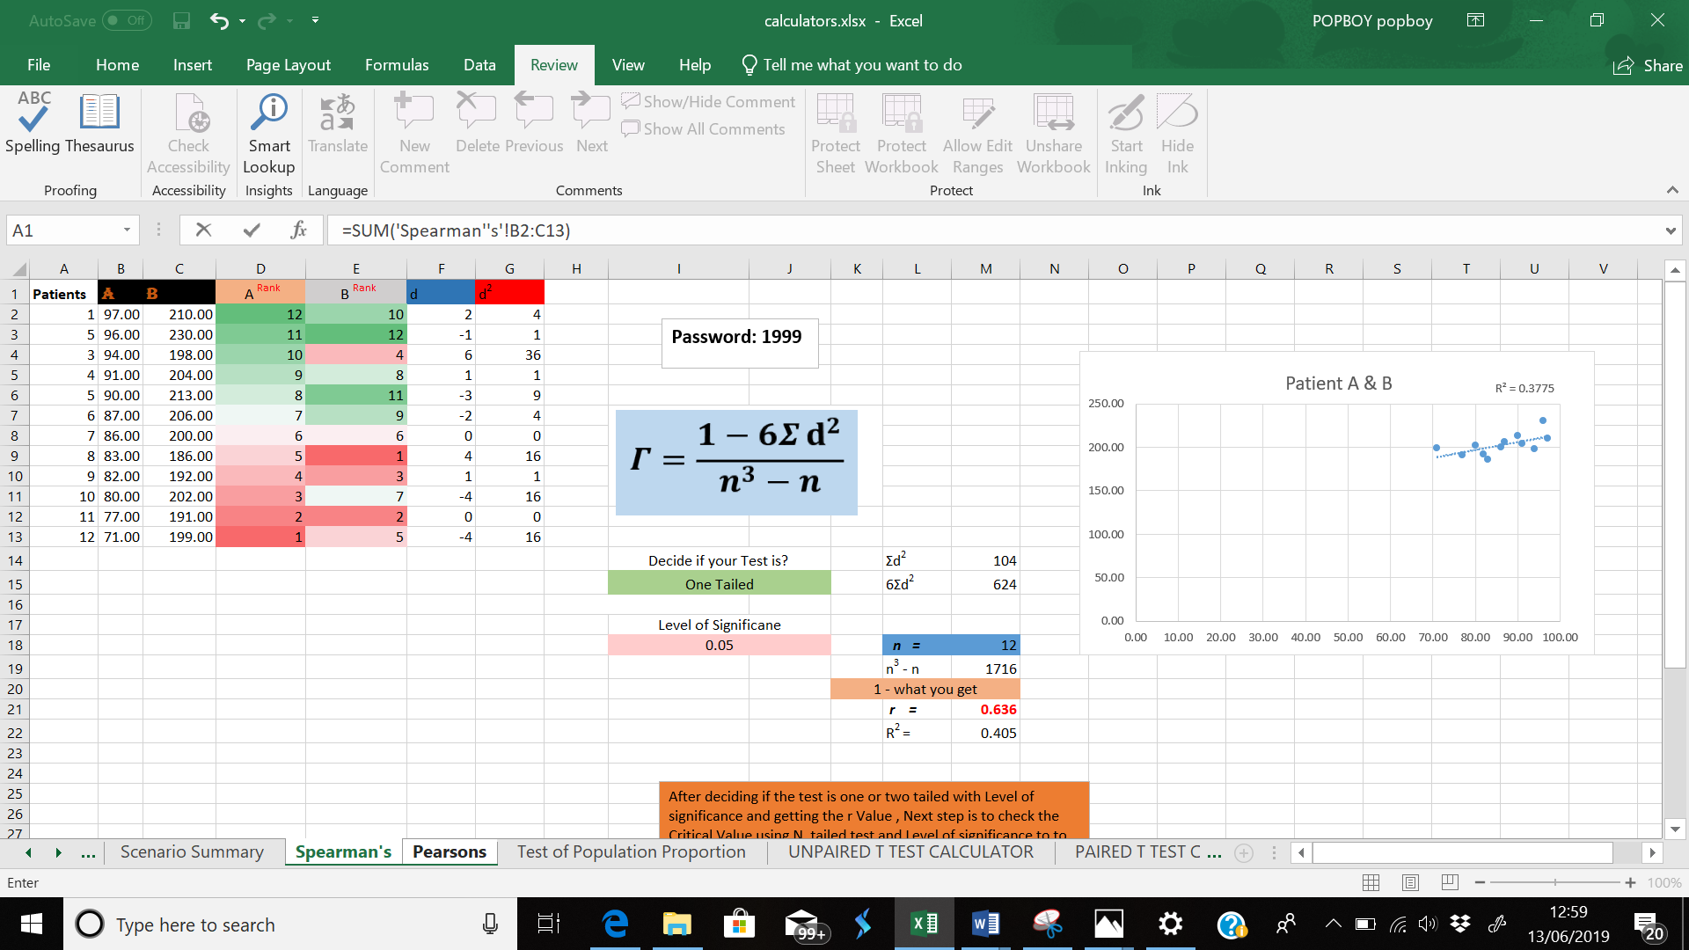And this is the first process in linking the sum of all values from B2 to C13 and after then trying out another method by summing up each Cell B and C

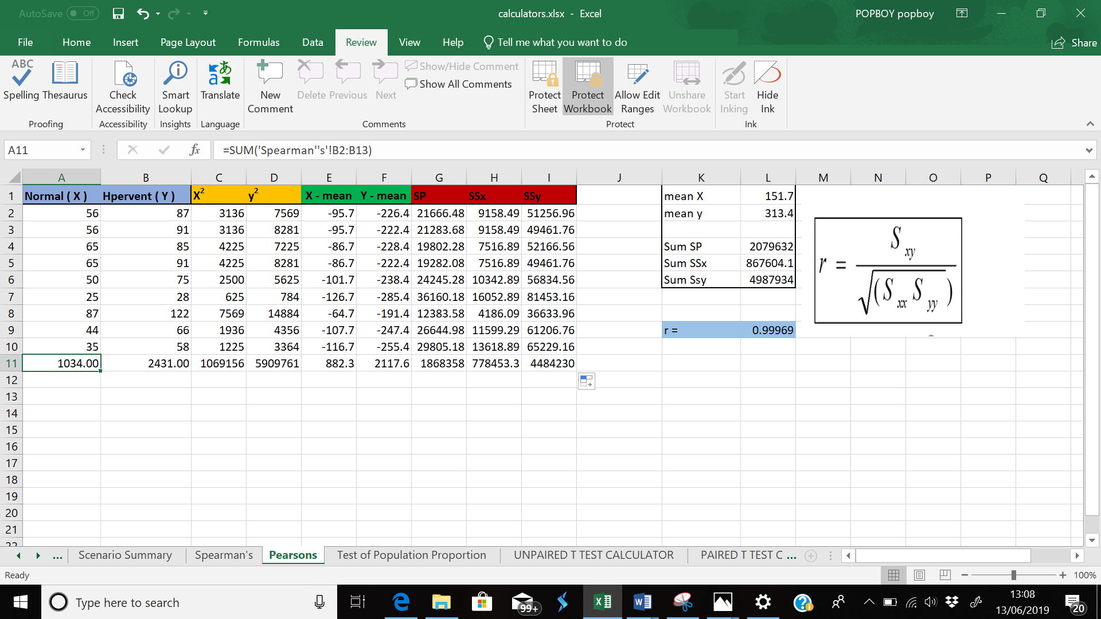

Using the the sum function and clicking on the sheets and cells I want excel to sum up, the formula to this is “**=SUM('Spearman''s'!B2:B13)”** and “**=SUM('Spearman''s'!C2:C13)”.**

**SS3.1**

The **ABS** function in **Excel** has just one purpose - to get the absolute value of a number. Where number is the number you want to get the absolute value of. It can be represented by a value, cell **reference** or another formula. Using the abs function have helped me with my Wilcoxon and sign test calculators

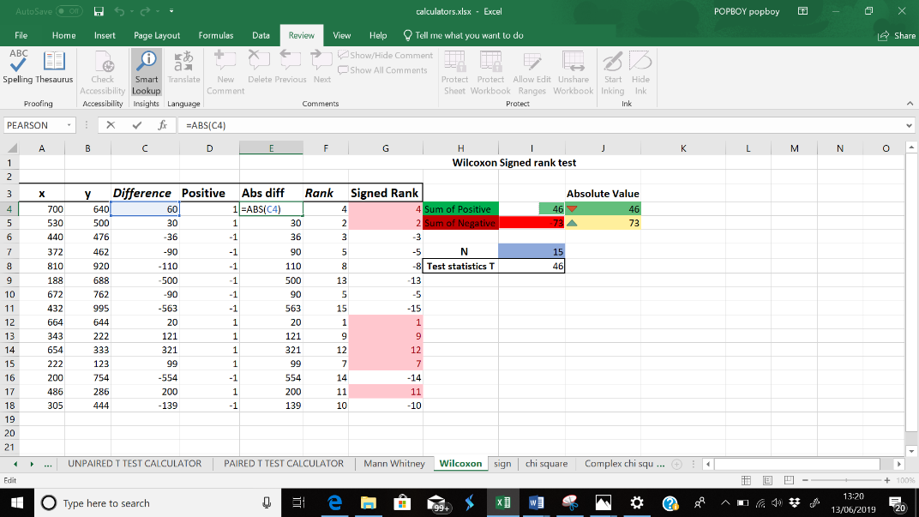

The absolute value was used in my Wilcoxon and sign text to display the value without any sign in my CELL E4 have used the absolute value to tell excel to make cell C4 an absolute value which then I highlighted down and all the values that are negative have been positive. Which is **“=ABS(C4)”**  
and for the Sign test I used it to give me absolute value for the two result which is displayed below **“=ABS(J4)”. Absolute value of cell J4 highlighted below**

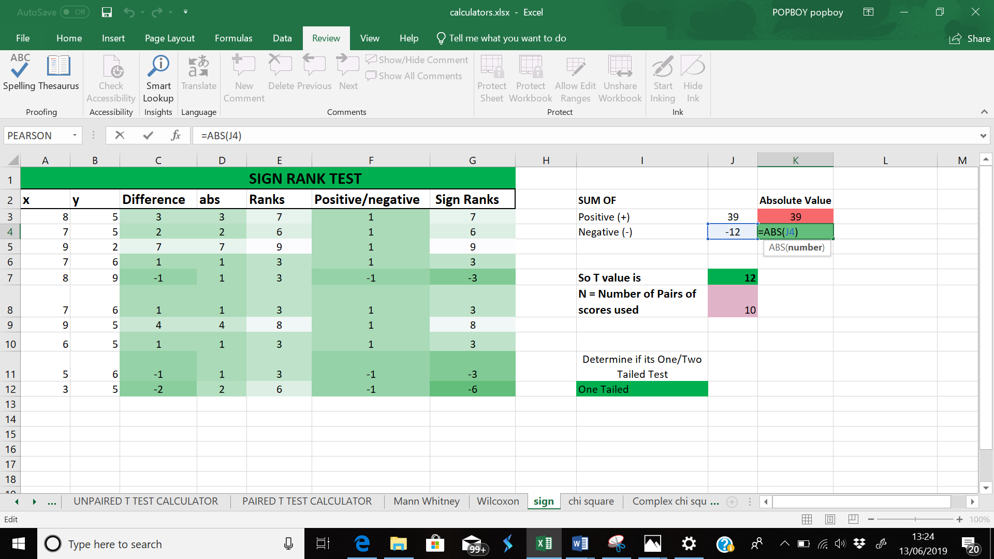

**SS3.3**

Using the if Fucntion for my sign test

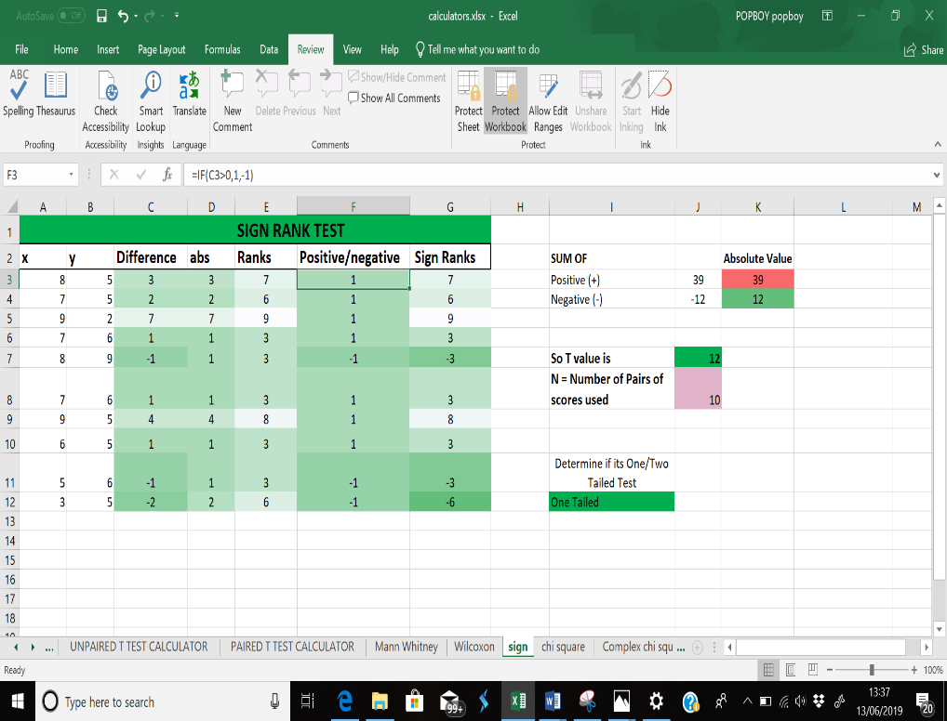

I used the if function to tell excel if cell C3 is greater than 0 It should display 1 and if is not it should display -1 in cell F3 and then highlighted it down for it to display on the remaining cells

Also used VLOOKUP, which is an Excel function to lookup and retrieve data from a specific column in table. VLOOKUP supports approximate and exact matching, and wildcards (* ?) for partial matches. The "V" stands for "vertical". Lookup values must appear in the first column of the table, with lookup columns to the right.

**“=VLOOKUP (value, table, col_index, [range_lookup])”**

value - The value to look for in the first column of a table.

table - The table from which to retrieve a value.

col_index - The column in the table from which to retrieve a value.

range_lookup - [optional] TRUE = approximate match (default). FALSE = exact match. But my range lookup function was to make it go to the exact column I want it to go and to do the coulumn I used the IF function.

Which have worked effectively with my Chi and Chi complex calculators

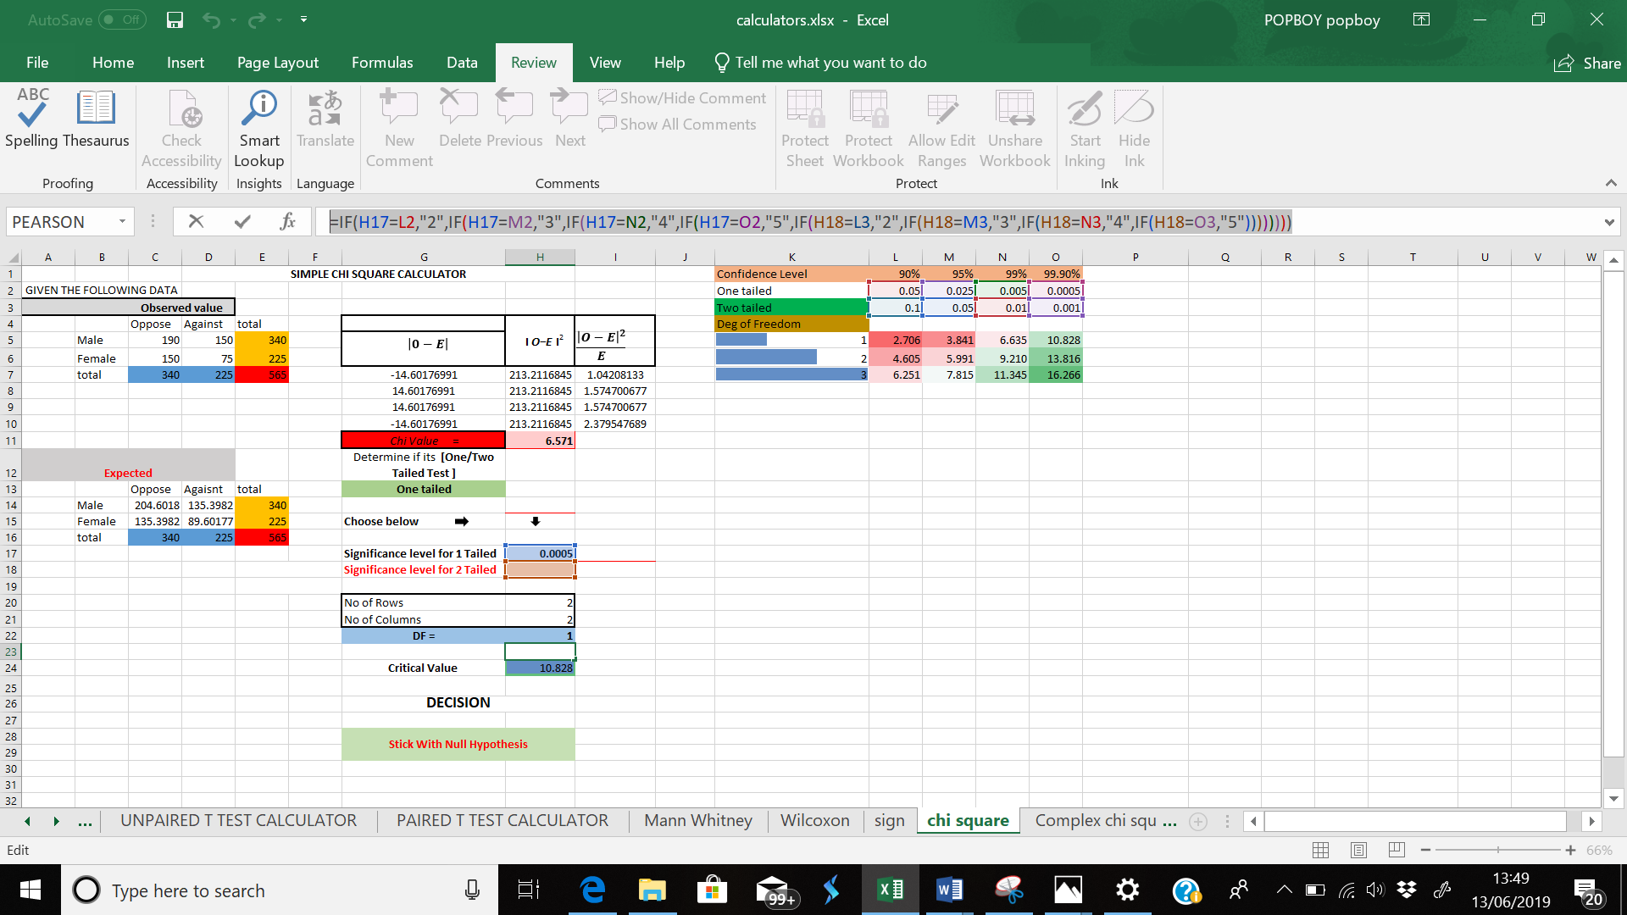

Using the IF function have told excel if cell H17 which is where the level of significance for 1 tailed test will be chosen is equals to any cell from L2 to O3 depending on the level of significance chosen that it should go to the column where it should be for example if level of significance is 0.05 1 tailed test that is =IF(H17=L2(which is 0.05 one tailed test on the critical value it should go to column 2 ).

And for VLOOKUP function have used it to get the critical value from the table below which is =VLOOKUP(H22,K5:O7,H23) H22 meaning the cell with the degrees of freedom, and highlighting the whole table which is K5:O7, and the column where I want the critical value to be gotten from which is done using the if function explained above and VLOOKUP is displayed below

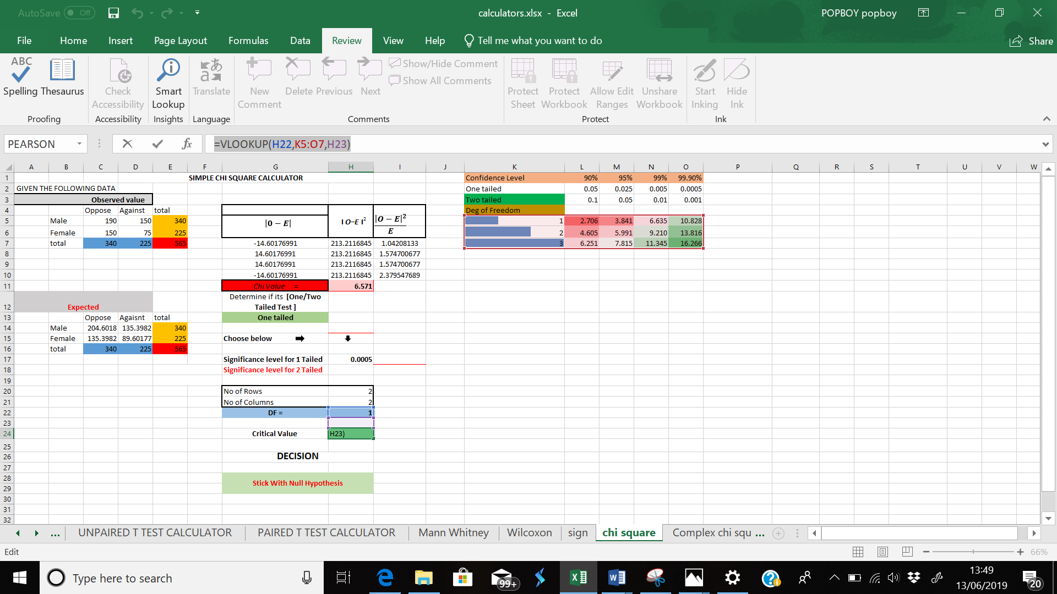

**SS4.2**

Charts provide a visual representation of your data, making it easier to analyze. For example, I created a scatter graph for my spearmens calculator to see if there is a pattern between A and B if there is a correlation between how the dotors rating from different patients

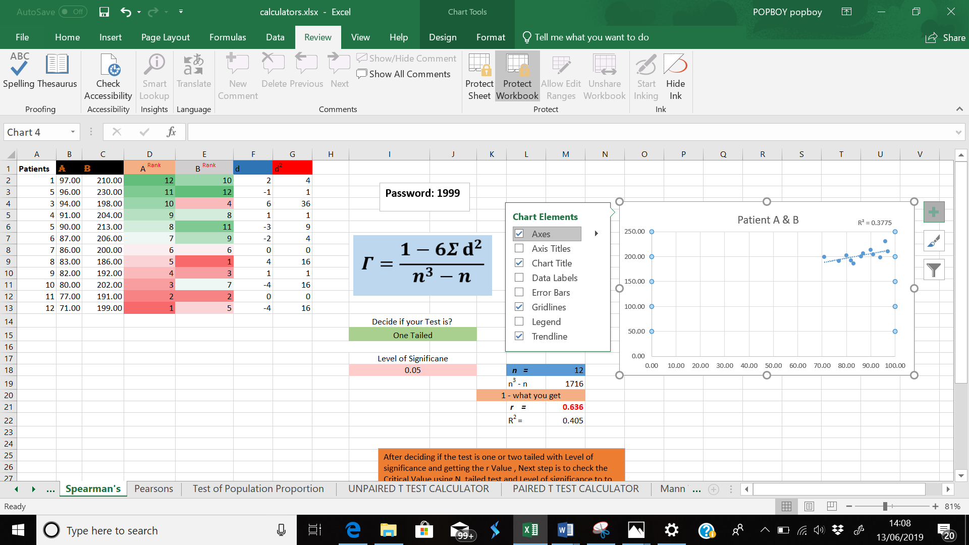

**Conclusion**

In conclusion have learnt new functions on excel and improved in my excel sheets , learning how to import data , telling excel to give comments after a results and creating at least a critical functional critical table on the chi square which I found interesting